AWARDS/CITATIONS

-

Employee of the Year for FSU Campus Recreation

Center, 2018-2019

-

American Red-Cross CPR/AED Professional

Rescuer, 2018

National Honor Society, 2018

PROFESSIONAL PROFILE

Hello, my name is Matt Demayo and I am a native from Tallahassee,

Fl. I aspire to someday to become a well renown actor to the

entertainment industry.

ACTOR

MATT DEMAYO III

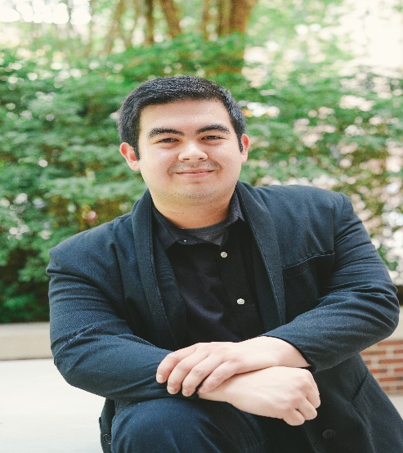

CONTACT DETAILS

Website:<https://mattdemayo7.wixsite.com/mattdemayo>h[https://mattdemayo7.wixsite.com/mattdemayohttps://mattdemayo7.wixsite.com/mattdemayo](https://mattdemayo7.wixsite.com/mattdemayo) g<https://mattdemayo7.wixsite.com/mattdemayo>

Backstage:

https://www.backstage.com/u/MattDemayo/

Email: matt.demayo@yahoo.com

ADDITIONAL SKILLS

Train in weightlifting, boxing, and high intense

-

intervals trainings.

Train into trouble shooting Fitness equipment

-

Plays music like guitar, piano, and drums as a

-

side hobby.

FILM & TELEVISION

I've been cast mostly in dramatic films.

ACTING EXPERIENCE

Supporting Actor in "The Hibachi Dinner" (Dir. Stephen

2019 -

Musumeci )

)

Supporting Actor in "Protectors of Life" (Dir. Jameel Karim)

2019 -

2019 -

Supporting Actor in "Payoff" (Dir.Nate Price)

2019 – Extra in “A Portrait of a Young Man” (Dir. Brandon Shenk)

2019 -

Supporting Actor in "Giddy" (Dir. Jameel Karim

)

2019 -

Extra in "A Separation" (Dir. Yalan Hu

)

2019 -

Extra in "In the Middle of Walt Whitman" (Dir. Sheree Chen

)

2018 -

)

Extra in "Ms. Piggy" (Dir. Tianying Jiang

)

Extra in "Bailey" (Dir. Will Harrison

2018 -

)

Extra in "An Altar of Sorts" (Dir. Brandon Shenk

2018 -

FLORIDA STATE UNIVERSITY

Bachelor's of Arts Degree in Theatre, May 2021

MY ACADEMIC HISTORY

-

Graduated with distinction (GPA

: 3.75)

-

National Honor Society

-

FSU Campus Recreation Center

-

Member of FSU WeightLifting Club

TALLAHASSEE COMMUNITY COLLEGE

Graduated Class of 2017

-

Honors List

-

Associate of Arts Degree

- Graduates with a GPA: 3.20